PortSwigger Web Security Academy — Proof of Concept

GraphQL API Lab 3

Finding a hidden GraphQL endpoint
Category | GraphQL API
Lab | Lab 3
Completed By | Security Researcher
Platform | PortSwigger Web Security Academy

Lab Objective
Discover and exploit a hidden GraphQL endpoint by manipulating the request structure.

Step-by-Step Exploitation
- Open Burp Suite and configure browser proxy.
- Navigate to the lab URL and identify the vulnerable functionality.
- Intercept the relevant HTTP request in Burp Proxy.
- Send the request to Burp Repeater for analysis.
- Craft and inject the appropriate payload into the vulnerable parameter.
- Forward the modified request and observe the response.
- Verify the exploit was successful as shown in the screenshots below.

Screenshots & Evidence
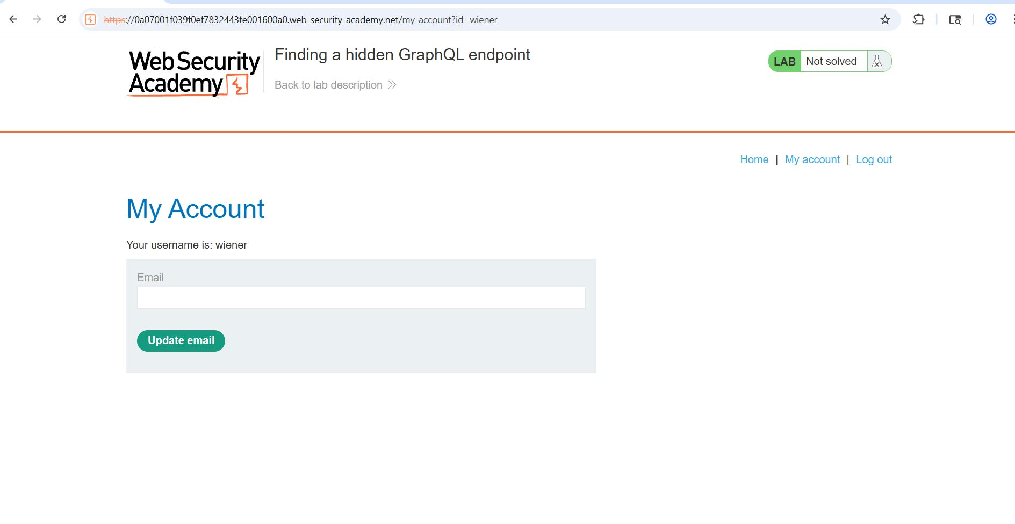
Figure 1: 1 Login With Use Id
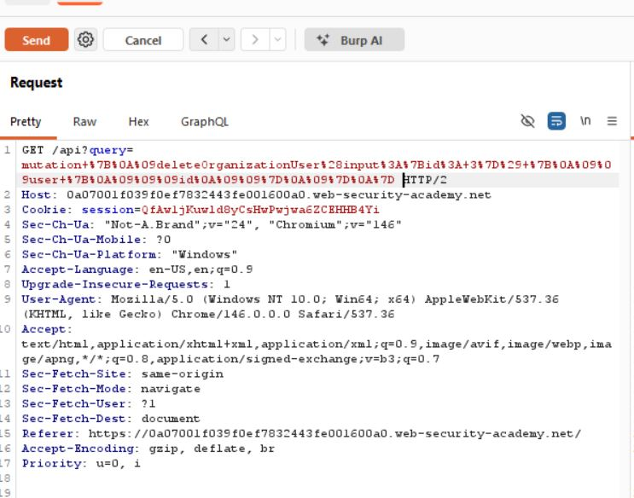
Figure 2: 10 Change The Header For Delete Carlo Accoutn
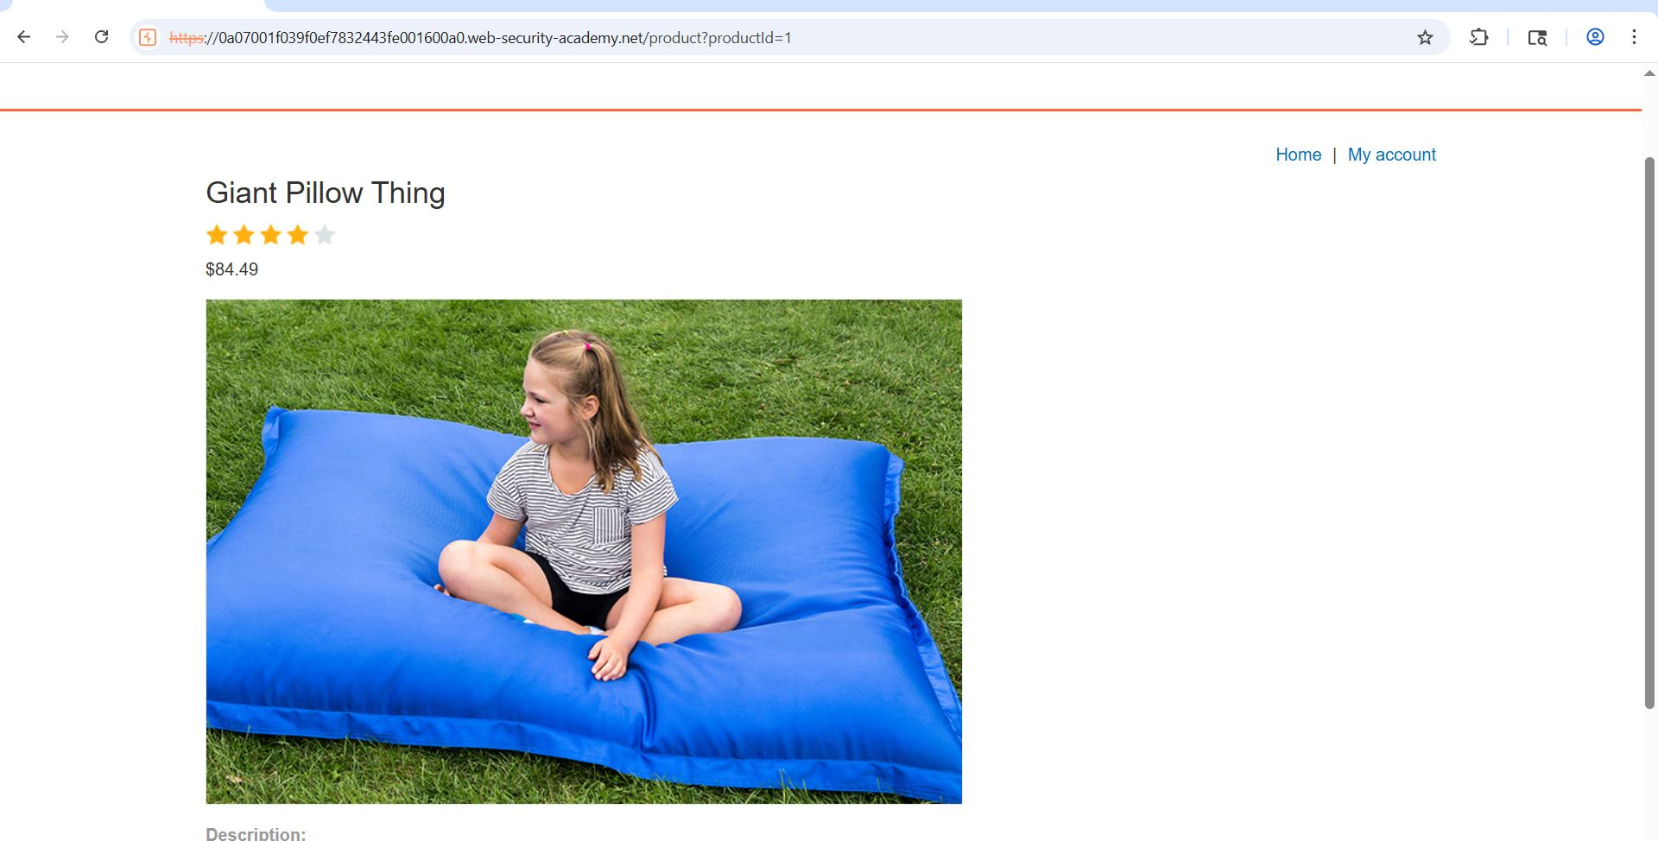
Figure 3: 2 Visit At Onne Product
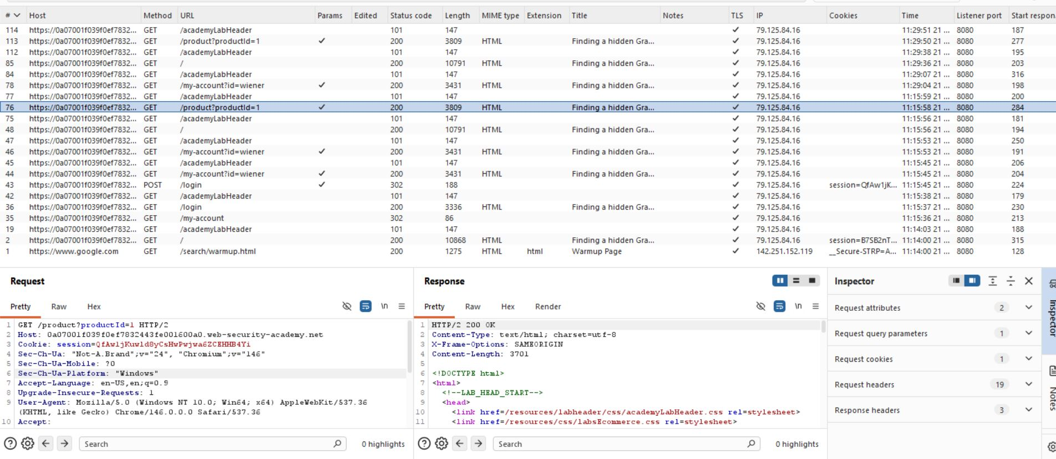
Figure 4: 3 Capture Request
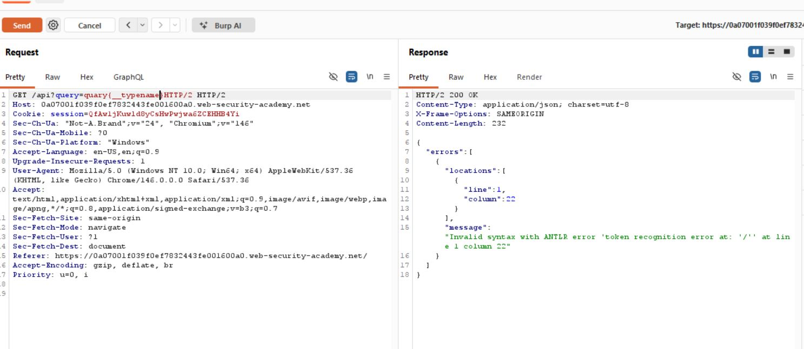
Figure 5: 4 Edit Reaquest Header Api
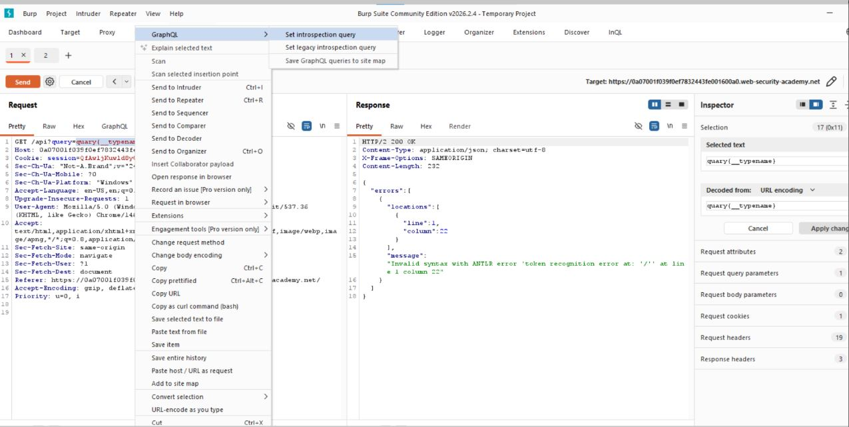
Figure 6: 5 Encript Quary Type
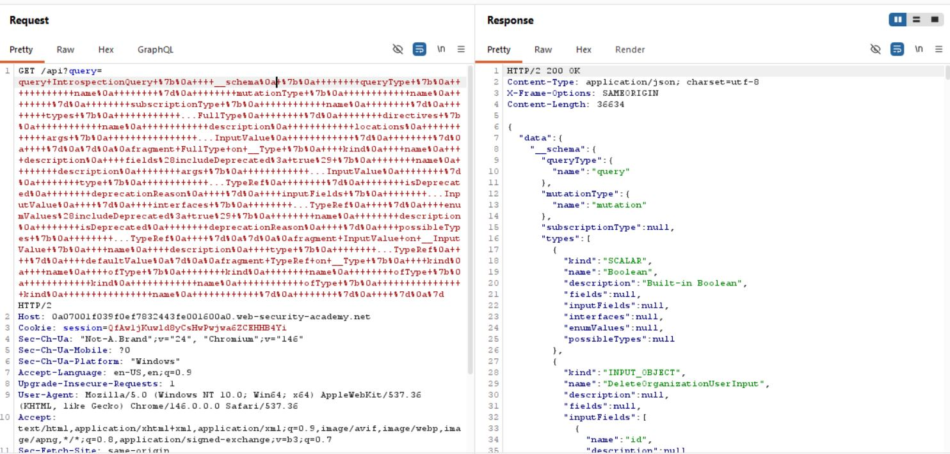
Figure 7: 6 Edit Schema%0a For Breake The Quary
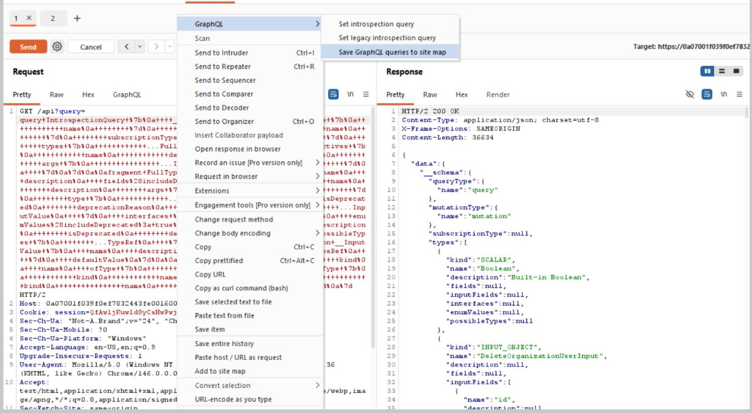
Figure 8: 7 Send It For Site Map
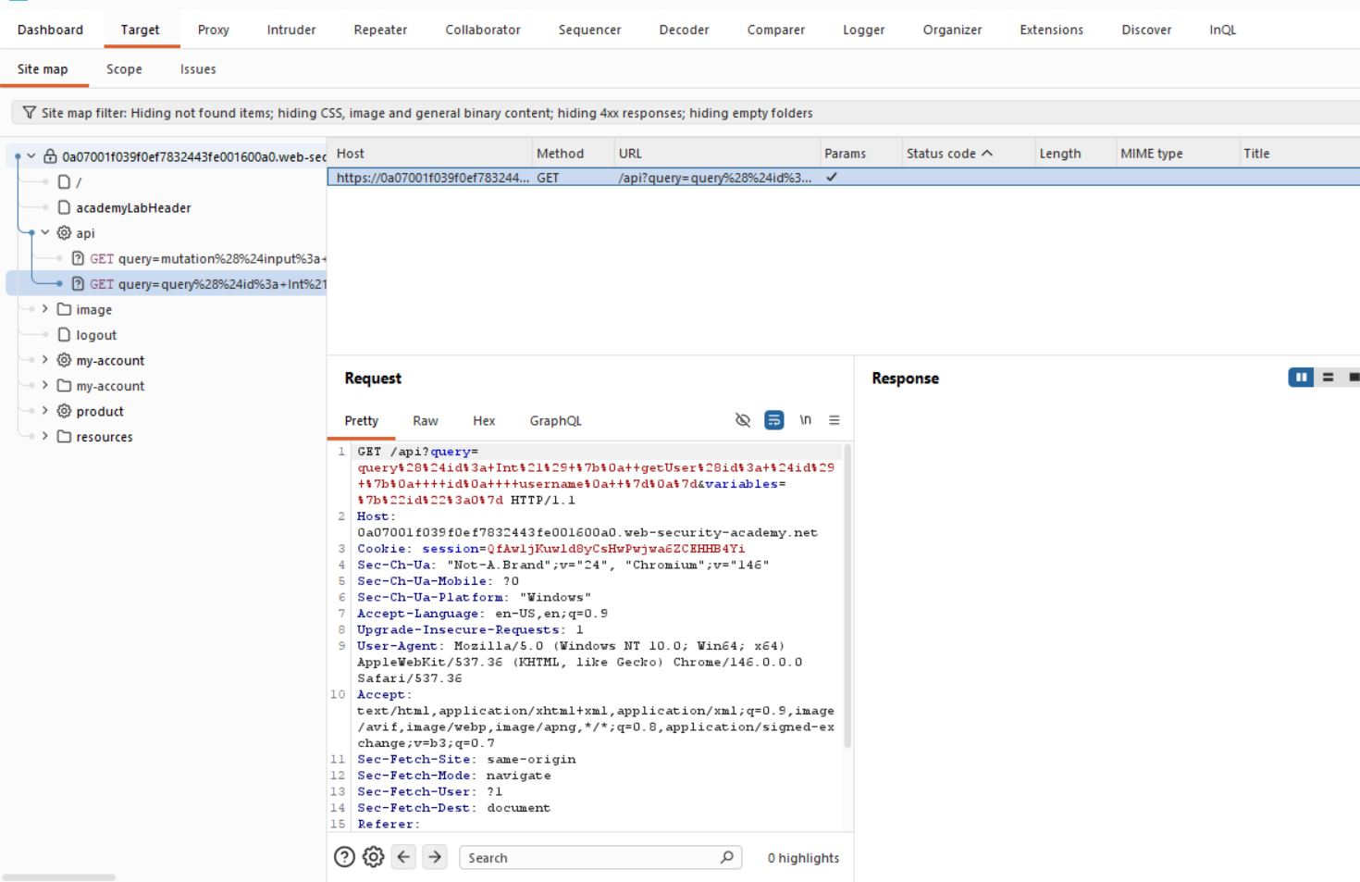
Figure 9: 8 Api Call
Lab Solved — Confirmation
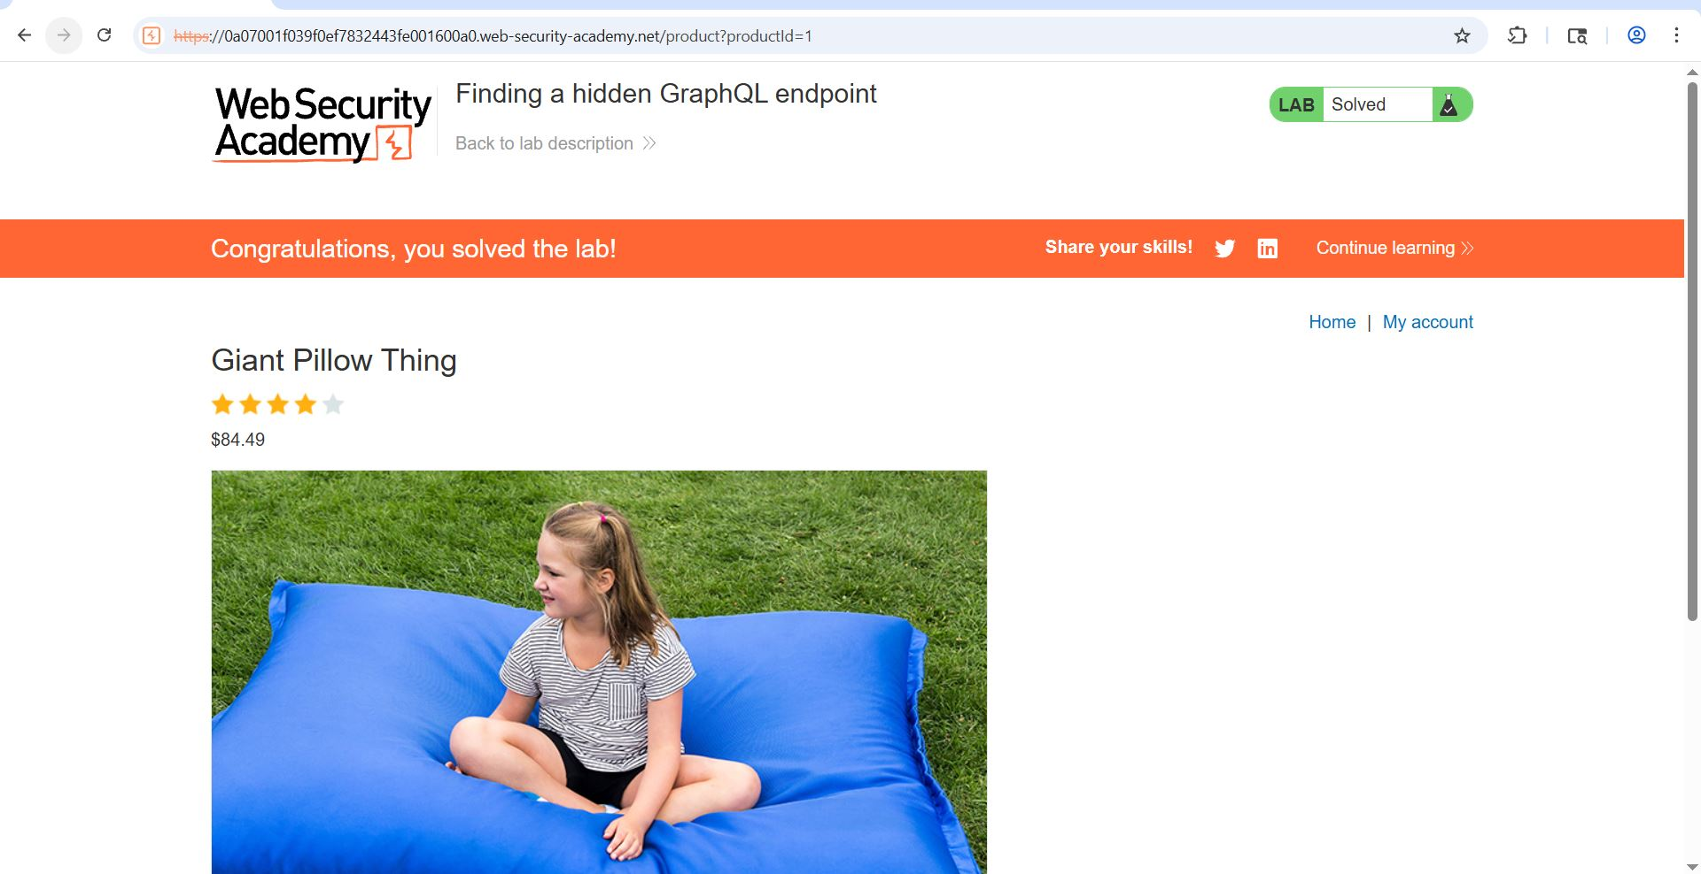
Figure 10: Final Pi C
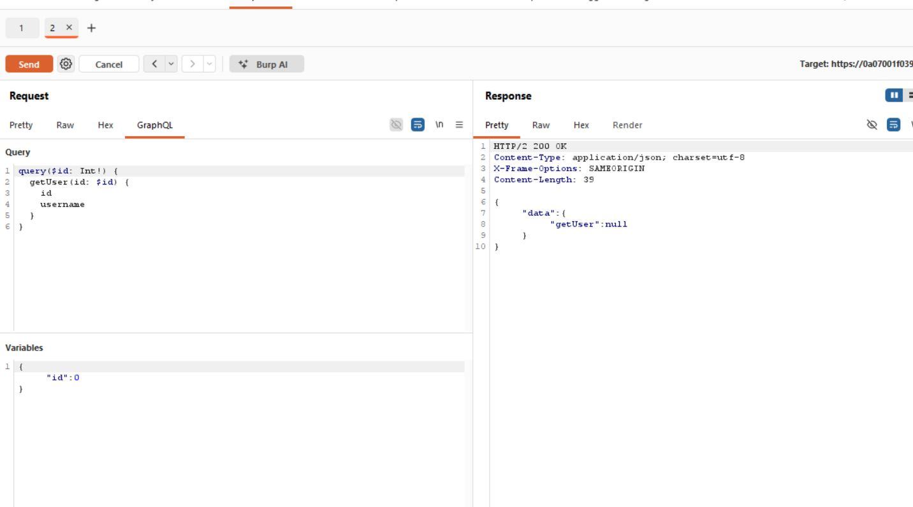
Figure 11: Id Value Cahnge 0 1 , 0 2, 0 3
Lab Solved — Confirmation
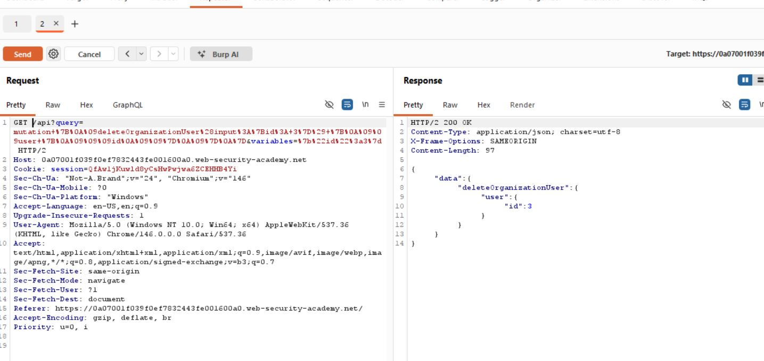
Figure 12: Last Second
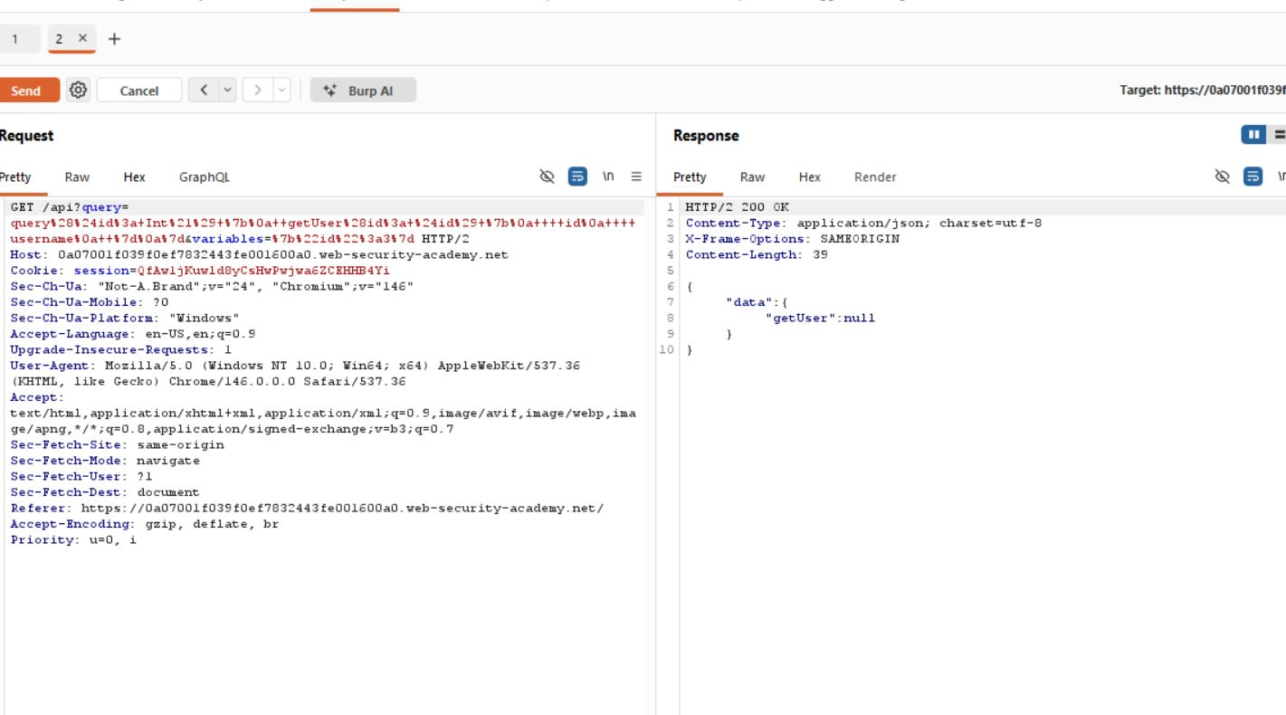
Figure 13: Sned The Latest Request To The Repeter From Api Call

Lab Status: SOLVED

